# Cover page

**Owl Atlas**

**Team Tortoise**



# Table of Contents

**Cover page** **1**

**Table of Contents** **2**

**Vision Statement** **3**

**Proposal** **4**

**Team Members** **5**

**Stakeholder Definitions** **5**

**User and System Requirements** **6**

**Use-Case Diagram** **8**

**Sequence Diagrams** **9**

**System Architecture Model** **10**

**Class Diagram** **10**

**Activity Diagram** **11**

**User Interface Diagram** **12**

**Database Diagram** **12**

**Reflection Statement** **13**

**Statement on Developmental Model** **14**

**Statement of Dependability** **14**

**Statement on Distributed Model** **15**

**Statement on Security** **16**

**Glossary** **17**

**Poster** **18**

**Brochure** **19**

**User Guide** **21**

**Team Resumés** **22**

# Vision Statement

To create a web portal that satisfies the needs of The Office of Orientation and Transfer Student Services. The functionality will include:

* New incoming freshmen/transfer students can register for orientation sessions,
* verify personal information,
* collect data via a questionnaire,
* and keeping a checklist of progress to completing all required steps as new incoming freshman/transfer students.

This website will serve as a medium for transparency between incoming freshmen/transfer students and The Office of Orientation and Transfer Student Services.

# Proposal

A new web-based Orientation Registration and Tracking tool will allow new students [to]:

* Log in with credentials sent to them
* Confirm personal information
* Fill out questionnaire
* Select a date for their orientation visit
* Use a checklist to ensure completion of registration process
* Make a payment using a “store” of many options

**High-Level Requirements**

The new system must allow the following:

* Check that the user has paid tuition before allowing them to register
* Orientation Department can configure each term, Summer/Fall or Spring, separately.
* The data for past terms must be archived in a way that continues to make it accessible
* Connect with TouchNet for payment services
* Show status of users of Pending/Pending Submission/Submission Received

**Deliverables**

1 – Website hosted onsite, may run on any platform.

**Timeline**

The program must be completed by December 1, 2017 for final testing before it becomes live on January 1, 2018.

**Funding Source**

The Division of Student Affairs will pledge a $7500 stipend for conference travel for the supervising faculty and a $250 per design group over the course of the Academic year (Fall/Spring) to the Principles of Software Engineering (CEN4010) class not to exceed $10,000.

The number of groups and dollar amount varies per semester and the deciding funding amount can be made by the supervising faculty.

# Team Members

Jarel Dhoman: Leader Michael Quach: Documentation

Julianne Beren: Front-end and Back-end Joe Grier: Back-end

Caroline Tyson: Front-end Sebastien Sterling-Adams: Front-end

# Stakeholder Definitions

*Developer*: Developers create the requested system itself. To facilitate the creation and quality assurance of this product, developers naturally have all of the permissions for this system as a superuser, potentially more (with access to associated databases, internal workings, and such).

*Student*: Students register for an orientation session. Students pay tuition, answer the questionnaire, choose an orientation date, and then attend orientation. If a student doesn’t pay their orientation fee, registration completion is prevented until the payment transaction is complete. If incorrect information is submitted by the student, then the student may go back to the questionnaire to change their answers accordingly.

*Student Assistant*: Student assistants can check in on the different statuses of the incoming freshman students and monitor orientation onboarding. Student assistants may access any information that is necessary to perform their duties. If a student doesn’t attend orientation, the student assistant may place a hold on the student’s account and email them necessary information to resolve this hold.

*Assistant*: Assistants can check in on the different statuses of the incoming freshman students and monitor orientation onboarding. Assistants may access any information that is necessary to perform their duties.

*Admin*: Admins can check in on the different statuses of the students and monitor orientation onboarding. Admins can access information before, during, and after student completes orientation process to change information or process non-attendees. Admins can add new orientation sessions to the calendar. Admins can add new or change existing questions on the student questionnaire, as well as delete any existing questions.

# User and System Requirements

m. User Requirement

n. Corresponding System Requirement(s), if any

STUDENT

1. Students shall be able to register for orientation.

1.1 After completing the form student’s submission status shall be updated within the database

1.2 Student shall be placed into the "form completed" tab of "admin view" under their appropriate semester term

1.3 After completing form students shall be sent to a confirmation page

1.4 Students shall able to save and exit the form before picking an orientation date

2. Students shall be able to login with credentials sent to them from SSO.

2.1 credentials shall be sent via an excel document, and inputted into the database

2.2 user credentials shall only be valid if the user has made a tuition deposit

3. Students shall be able to fill out questionnaire and make desirable changes based on needs of client.

3.1 Student shall be able to specialize their onboarding process by making selections during the questionnaire portion

3.2 Upon selecting specific options the page shall change to accommodate the necessary information required

4. Students should be able to access a module to help resolve possible issues with the orientation registration process

4.1 This module shall serve as a medium to resolve issues between students and The onboarding process, regarding completion of the orientation process

4.2 Students shall be able to submit a ticket, stating their current issue

4.3 Student Assistants shall be able to address and resolve these issues through the admin view capabilities allowed to them by the client

5. Students shall be able to make changes to form after submission.

5.1 Students shall be able to make changes after submission reflecting the needs of the client

5.2 After arrangements for the students' orientation date have been made the student shall not be unable to cancel their orientation day or reschedule

6. Students shall be able to pay for orientation during the registration process.

6.1 Student shall be able to pay for their orientation through “TouchNet”

6.2 Student shall see two views based on whether the “TouchNet” process was successful or failure

6.3 Student will have to pay through “TouchNet” if a failure signal is sent to the php document the user shall be prompted to pay before proceeding

6.4 If a success signal is sent the user will be allowed to proceed to the finalization page

DEVELOPER

1. Developer shall have access to all modules.

1.1 Developers will be able to access all working components of the orientation application to satisfy changing needs of the client

1.2 Access all modules to address errors that may occur during orientation process

2. Developer should have filled out some form to protect user information.

2.1 Any sensitive information that the client deems should be confidential should be addressed by this contract between developer and client

3. Developer shall be able to make changes to database and system based on the needs of the client.

3.1 If the questions to be asked are changed, then such changes shall be easily reflected in the system and database.

ASSISTANT STUDENT

1. Student Assistant shall be able to resolve issues students encounter during orientation registration.

1.1 The SA shall be able to view the contents of the system to diagnose any obvious issues.

1.2 If a database value must be changed; the SA shall contact an admin or assistant who may choose whether to make the change.

ASSISTANT

1. Assistant shall have all permissions of Student Assistant.

2. Assistant shall be able to generate reports dealing with orientation process.

2.1 Reports shall be generated by the system when requested.

2.2 The exact layout and contents of the report depend on the client’s needs.

3. Assistant shall be able to set orientation dates.

3.1 The Assistant shall be able to designate a time, date, place, price, and occupancy limit of a new orientation instance.

3.2 The Assistant shall be able to change any of the above details up to two weeks before the actual orientation will occur.

4. Assistant shall be able to export reports based on their admin needs.

4.1 Reports shall be exported by the system when requested.

4.2 The exact layout and contents of the report depend on the client’s needs.

ADMINS

1. Admin shall have all permissions of Assistant.

2. Admin shall be able to change user type either permanently or temporarily.

2.1 As a top-level user, an admin shall be able to adjust the permissions of other users as required.

2.2 One admin shall not change the permissions of another admin.

3. Admin shall be able to generate reports based on their needs.

3.1 Built-in operations, whether automatic or as requested, shall be available to produce reports for staff analysis.

3.2 Whether an operation is automatic depends on the needs of the staff.

# Use-Case Diagram

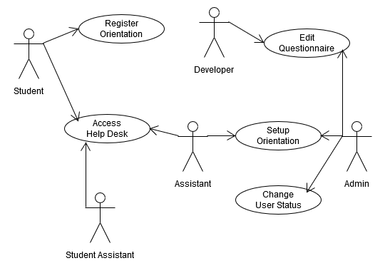

# **Sequence Diagrams**

# System Architecture Model

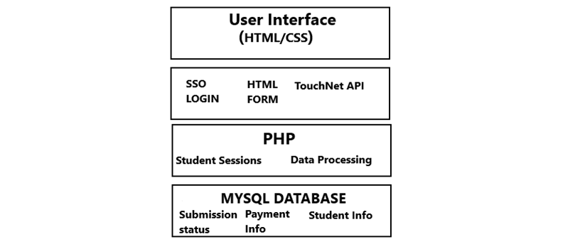

# 

# Class Diagram

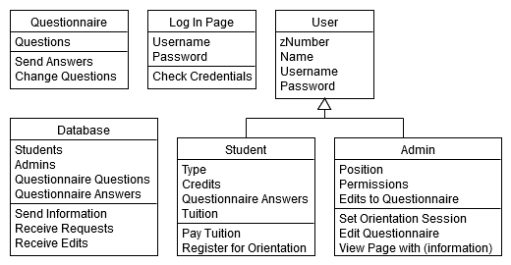

# Activity Diagram

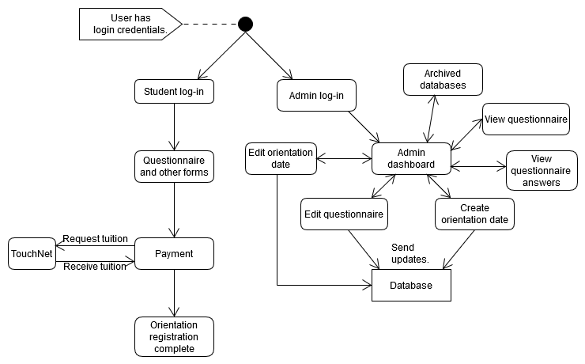

# User Interface Diagram

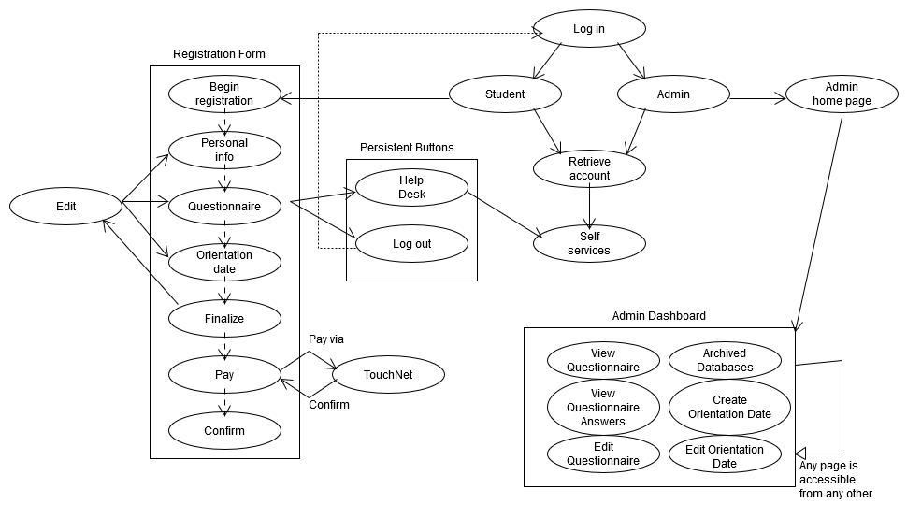

# Database Diagram

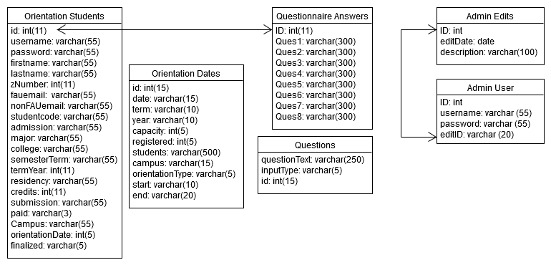

# Reflection Statement

1. Team Dynamics
   1. The Team was very congruent in how we addressed implementation of orientation system, and functionality that came with it. As a team, we would get together every week (including Thanksgiving week) to decide what functionality we would strive for that week. There were never any issues getting team members onboard when it came to contributing.
2. Difficulty of getting team members to do their part
   1. There were no difficulties rallying team members to do their part. As a team, everyone fulfilled their duty when it was assigned to them. However, issues did arise in getting the team to juggle other classes alongside this project, but it never affected the ability for team members to play their part.
3. Sickness, absences, and excuses
   1. All group members were able to meet once a week even if they had other obligations, they would reschedule with the team leader and work something out. Absenties did not impact group performance because team members communicated through the group messaging platform “Discord”.
4. Biting off more than you can chew as a project leader, programmer etc…
   1. As a group we focused on narrowing down the high priority functionality presented in the proposal and accounting for functionality presented by the client during their meetings.
5. New skills learnt – programming, languages, documentation, communications, and so forth
   1. Sebastien Sterling-Adams: I learned valuable front-end development skills. Further improved my skills interacting with team members and coordinating
   2. Julianne Beren: Improved PHP and MySQL, improved communication skills, creating sessions through PHP
   3. Caroline Tyson: Learned PHP and MySQL, improved communication skills, gained experience programming with a group
   4. Michael Quach: How to use UMLetino to create class, sequence, activity, etc
   5. Joseph Grier: Honed Stack Overflow skills, learned MYSQL & PHP, learned database schemas, and structuring of a database etc.
6. Techniques used to rally team
   1. Use of Discord, e-mail, and text messaging to keep group working towards the vision statement and implementing high-level functionality
7. Challenges of having remote teammates
   1. No issues were encountered during the semester when it came to meeting on campus with distanced learning teammates.
8. Communication barriers
   1. No communication barriers were experienced.
9. Inspirational-notes and testimonies [sic]
   1. Bullard’s lectures and stories.

# Statement on Developmental Model

Our group collaborated using a mix of both waterfall and agile development for this project. Specifically, after the project groups were established, we found a time for each week in which we were all free and chose to meet up at this time weekly. These meet-ups were used to communicate any and all concerns to the rest of the group, as well as keep each other up-to-date on any development that had occurred, both in the to-be-delivered project and in any planning that we had done. In addition, an online communication medium was established for all members of the group to use outside of meeting times, as well as to store any resources that we found so that the entire group had quick and easy access to all resources found. The weekly meetings constitutes the agile portion of the developmental model. However, as far as actual development of the project went, portions of the project were divided in a rather linear fashion. We began with initial planning, of course, moved on to front-end development, and then finished up with the back-end. Polishing and a few minor but extra features were added in the interims and performed at the end, when everything was done, but the overall development was very much linear, owing to the waterfall portion of the development.

# Statement of Dependability

Availability: The website’s files will be moved to FAU’s servers, allowing access to the project site as long as access to FAU itself is possible.

Reliability: All content is either stored in stable local (will-be server) files or in stable MySQL databases, giving little room for unexpected results to occur, resulting in high reliability.

Safety: This is a purely virtual product and therefore cannot harm any consumers.

Security: Any sensitive information is only stored in the corresponding database. All databases are readily accessible by only administrators.

Resilience: There is no opportunity for users to provide input that can permanently damage the entirety of the system. Highly resilient.

# Statement on Distributed Model

Resource Sharing: This project requires information that is obtained from other departments, such as zNumbers and student e-mail addresses. Very specific information that is obtained from this system may be shared with other departments, such as whether the student is a veteran.

Openness: This project only uses MySQL databases via phpMyAdmin. All other content is saved in the host server.

Concurrency: No part of the project uses nor requires concurrent processing. All information requests and changes to the MySQL database are done on-demand, which requires waiting for user input and therefore lacking any room for concurrency.

Scalability: The workings of the project may be changed such that it is more familiar to the consumer, but there may not be much opportunity to improve upon its structure without entirely scrapping it. However, new functionality, such as new buttons on existing webpages or entirely new webpages, are simple to implement.

Fault Tolerance: There is little room for users to give unexpected or improper input. At worst, improper input from a student user will cause the page to deny progress until proper input is given. Improper input from an administrator may be obtained from changing the questionnaire. This may constitute adding content that is not a question for a student to be asked. Such improper input is difficult to prevent, so it must be monitored by the administration to prevent serious problems. However, to aid in mending such issues, administrative changes are automatically logged.

# Statement on Security

What are you protecting?

We protect the answers that students give to the questionnaire. User login credentials are handled by the Single Sign-On service that is currently implemented by the consumer. Payment transaction information is handled by the TouchNet service that is currently implemented by the consumer and will be integrated into the project.

Why is it important (#1) to protect?

Questionnaire answers as information may not be incredibly valuable, but allowing changes to such information by a third party may hinder the student’s attendance to the institution. In addition, we do not request permission to share the answers; thus, the student should trust the institution to not share it, so the project does its best to facilitate this protection of privacy. After all, it is all too easy to lose one’s trust and equally difficult to regain it.

How are you protecting it (#1)?

The protected information is kept inaccessible to any individual that does not have access to an administrative account or the student’s account (via editing current responses). The only other way to access such information is via the MySQL server itself, which requires the owner’s phpMyAdmin credentials. No one outside of this group knows of these credentials, and FAU account credentials are not within the group’s jurisdiction.

What is your security policy?

Treat the consumers’ information as we would treat our own. If they don’t tell us to share the information, we will not.

# Glossary

*Admit type*:

* ST – Standard
* TL – Transfer with less than 60 hours
* FC – FTIC less than 12 College Credits
* RF – Returning former (Doesn’t have to do orientation)

*Archive*: Database tables that were used for previous semesters. Maintained for historical purposes.

*Dashboard*: The administrator home page, where admins are directed to immediately after logging in.

*Orientation Session*: An event which occurs at a specific time in which a group of students are introduced to the campus by orientation staff. Also called an *orientation date.*

*Pending*: Status indicating that the student has not finished registration.

*Pending submission*: Status indicating that the student’s orientation registration was successfully submitted, but is awaiting payment.

*Questionnaire*: A series of questions that the student must answer in order to register for an orientation session. Questions may be changed by an administrator.

*Residency*:

* F – Florida resident
* N – Non-Florida resident
* R – Florida resident alien
* T – Florida resident special category
* A – Non-resident alien
* E – Non-Florida resident alien

*SSO*: Single Sign-On, an external authentication service that allows a user to access multiple applications with one set of login credentials.

*Student Type*:

* J – Transfer from inside Florida
* U – Transfer from outside Florida
* B – FTIC Beginner
* E – FTIC Early Admit
* S – 2nd Bachelors (Doesn’t have to do orientation)

*Submission received*: Status indicating that the student was successfully registered for an orientation session.

*Ticket*: A form submitted via the Help Desk to request help from a staff member.

*TouchNet*: An external service that serves as a payment medium. Used when the student is paying the orientation tuition.

*Tuition*: A fee which the student must pay via TouchNet before their orientation seat can be reserved.

# Poster

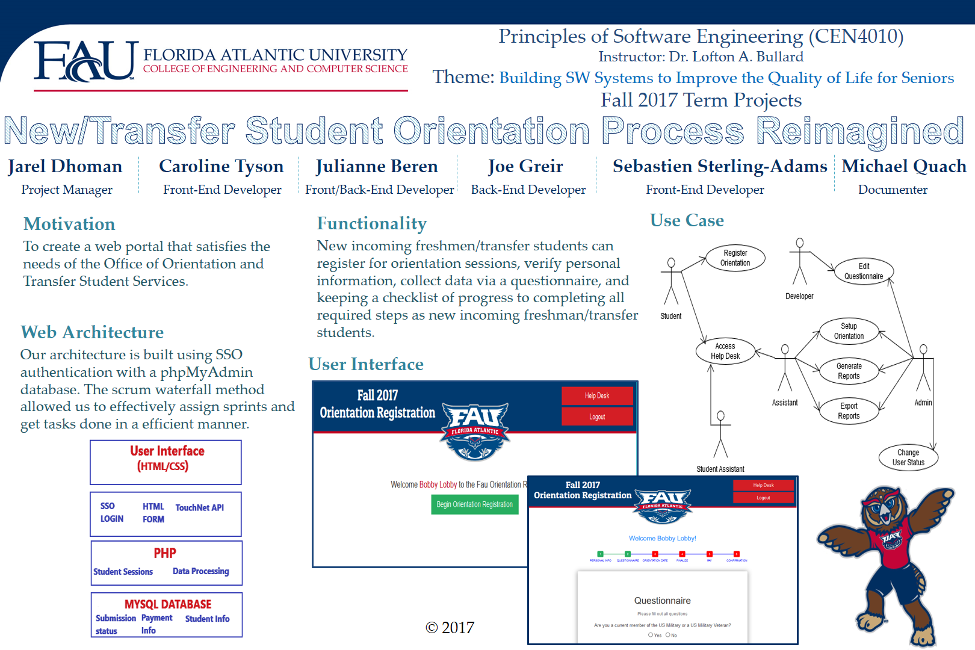

# **Brochure**

# User Guide

Go to the site. Click on the student tab if you’re a student or the admin tab if you’re an admin. If you logged in as a student and haven’t registered yet, answer each question that’s shown honestly and then click “Next” when appropriate. Once you reach the confirmation, make sure that all of the information that you gave is current and accurate. Then comes the payment portion, where you give FAU its money and then enjoy the gif of an owl. Log out when you’re done enjoying it.

If you logged in as an admin, you will be taken to the admin dashboard where you can access any other page via the sidebar. The archives will allow you to see past semesters’ information. You may add new orientation sessions and change the questionnaire’s contents. You may view the statuses of various students’ progress through the orientation registration. When you are satisfied with whatever you needed to do, log out.

# Team Resumés

**Jarel Dhoman**

**7619 Silver Woods ct, Boca Raton 33433**

jdhoman2014@fau.edu (917**) 710-1825**

**EDUCATION**

Florida Atlantic University, Boca Raton FL Summer 2017

Bachelors of Science in Computer Science GPA: 3.3 / 4.0

**COMPUTER COURSES***: Foundations of Computer Science(C++), Data Structures, Intro to Internet Computing, Stochastic Models for Computer Science, Database Systems Operating Systems, Design/Analysis of Algorithms*

**TECHNICAL SKILLS**

Languages: C/C++, JavaScript, PHP, Python, SQL, Visual Studio

Web Development: JQuery, HTML5, CSS3

Operating Systems: Windows

Software: MS Office

**ACADEMIC PROJECTS**

**Team leader**

**Orientation Registration System** *(Software Engineering, Fall 2017)*Designed and created an Orientation registration system for FAU’s department of student affairs. The application includes web-based administration database controls, and use of numerous queries to send a receive information from our own database to retrieve, validate, store user information.

· *Tools used: Illustrator, MS Office, Brackets, MAMP, Google Chrome*

**WORK EXPERIENCE**

Silver Star Auto Express, Queens, NY May 2017 – August 2017

*Computer Specialist*

Provide technical support and information about mechanic software.

**Sebastien Sterling-Adams**

West Park , FL | ssterlingada2013@fau.edu | (954)647-6127

# Education

Florida Atlantic University Boca Raton, FL

Bachelor of Science in Computer Science

# RELEVANT COURSEWORK

Introduction to Programming, Foundations of Computer Science, Data Structures, Discrete mathematic, Internet computing, Microprocessors, Calculus 1&2, Python Programming, Design Analysis

# TECHNICAL SKILLS

Languages: C/C++ , Python

Operating Systems: Windows, IOS

Software: MS Office

# WORK EXPERIENCE

Bookseller Pembroke Pines, FL

*Computer & Tablet Specialist* October 2016 - Present

· Making Connections with customers to help determine which book fits their needs.

· Working with a team, to aid customers with extraordinary customer service.

· Managing money in use of the Cash Register

Camp Wah-Nee Torrington, CT

*General Counselor* June-August of Summer 2016&2017

• Encouraged children to push themselves when they needed to be able accomplish tasks

• Coached teams of various sports

• Supervising children for 7 weeks making sure they are properly cared for

• Worked intensively with other counselors to actively keep happy environment.

Macy’s Aventura, FL

*Sales Associate* November 25, 2014 – January 6, 2015

· Meeting and making a connection with customers, asking questions and listening to shoppers' needs, then giving options and advice on meeting those needs.

· Inspiring the customer to buy, celebrating the purchase, and creating a lasting positive impression of you, Macy's, and the purchase.

· Regular, dependable attendance and punctuality

**Julianne V. Beren**

**3005 Blue Jay Drive, Cooper City, FL 33026**

jberen2016@fau.edu (954)-579-6270

**EDUCATION**

Florida Atlantic University, Boca Raton FL December 2017

Bachelors of Science in Computer Science

Minor in Mathematics

GPA: 3.67 / 4.0

Broward College Class of 2015 - Associate of Arts Honors Program

Memberships:

*Society for Collegiate Leadership and Achievement Honors Society*

Phi Theta Kappa Member

*Computer Courses:* *Intro to Computer Programing(Python), Intro to C++, Intro to Logic Design, Foundations of Computer Science(C++), Data Structures, Intro to Microprocessors(Assembly and C), Intro to Internet Computing, Stochastic Models for Computer Science, Database Systems, Web Services, Operating Systems, Design/Analysis of Algorithms, Artificial Intelligence, Programming Languages(CLISP and Python),*

*Math Courses: Calculus with Analytical Geometry (1, 2, 3), Differential Equations, Discrete Math, Modern Algebra, Honors Statistics*

**TECHNICAL SKILLS**

Languages: C (beginner level), C++ (Intermediate level), Python (Intermediate Level), Assembly,

Basic (beginner level)

Web Development: HTML, CSS, JavaScript, jQuery, PHP, SQL, node.js, EJS – (all intermediate level)

Software: MS Office (expert level), Visual Studios 2015 (intermediate level), Quartus Altera (intermediate level), Brackets (intermediate level), Code Composer Studios (beginner level)

**WORK EXPERIENCE**

Publix Supermarket, Cooper City, FL October 20, 2007 – January 2018

*Customer Service Staff*

Provide excellent customer service and satisfaction within a successful business setting.

***Job Duties****: Team Leader/Role model in charge of cashiers and baggers regarding adherence to policies and procedures, responsible for large sums of money (Western Union, Lotto, money orders, cash drawer), cashier trainer, and overall customer service representative for employer.*

Nextera Energy FPL, Miami, FL May 15, 2017 – August 17, 2017

IT Programmer Analyst Intern

***Job Duties***: Design, code, test, debug, and document programs and maintain

Created an automated self-service dashboard website on corporate portal. The dashboard displayed the IT Infrastructure Technology - Enterprise Systems Management Team’s applications health metrics, using node.js, express web frameworks, server and client-side API calls, and utilizing a cloud database with IBM BluemIx Cognitive Services (PAAS – platform as a service). Responsible for displaying live critical, confidential data to authorized users.

By implementing this dashboard, I eliminated manual labor for reporting purposes, strengthened automation to streamline the reporting process, and made one centralized place with most up to date current information.

Learned Agile and Six Sigma practices – certified White Belt

Applications displayed – BigFix, Remedy, Mobility, Patching reports, Cloud applications, business approvals

**INTERPERSONAL SKILLS**

· Detailed-oriented

· Dedicated and diligent

· Team player

· Trustworthy and dependable

· Creative and artistic

· Self-managed

· Able to work well with people on all levels

· Ability to learn new skills quickly and accurately

· Level-headed in tough situations

· Good at identifying a problem, dissecting it, examining options, setting up strategies, putting plan into effect, and monitoring its progress. (Implemented on school projects and in the work place)

**Caroline Tyson**

3733 Valley Park Way

Lake Worth, FL 33467

(561) 951-1012

ctyson0723@gmail.com

**Work Experience**

**Joann Fabrics and Crafts**

**April 2016-Present**

**Team Member**

· Help customers find the items and fabric that is best for their project

· Cut fabric to customers’ specifications

· Clean and maintain the store and merchandise

**CAT Technologies**

**Winter 2014-Summer 2016**

**Secretary**

· Created a database of government blueprints for machine shop

· Some light manufacturing and manual assembly work

**Volunteer Work**

**Lion Country Safari Camp**

**2007-2012**

**Counselor in Training**

· Monitored youth during activities

· Assisted with group activities

· Cleaned up messes when necessary

· Assisted children with feeding various zoo animals

**Education**

**Florida Atlantic University**

· Anticipated graduation in 2018

· Majoring in Computer Science

**The King’s Academy**

· Graduated 2013

· Received award for over 400 hours of community service

**Joseph C. Grier**

**Cell: (561) 445-9697**

**Joegrier47@yahoo.com**

**6765 Bridlewood Ct Boca Raton, FL 33433**

**Education:**

**Florida Atlantic University Boca Raton, FL (Currently Enrolled)**

● Class of 2018, Computer Engineering

● 3.0 GPA

● Member of GUILD

● Member of the National Society of Collegiate Scholars

**Professional Experience:**

**January 2017-Present Partech Inc. Boca Raton, FL**

**Hosted Services Intern**

● Work on various Infrastructure as Code assignments utilizing Powershell and Amazon Web Services

● Monitor and diagnose problems in the entire Cloud infrastructure (NOC duties)

● Work on ChatOps projects utilizing Coffeescript and Powershell, integrated into Slack

**June 2016-August 2016 FAU College of Nursing Boca Raton, FL**

**IT Tech Assistant**

● Troubleshooting hardware and software issues

● Replace various computer components

● Diagnose and wipe hard drives

● Update and maintain computers throughout the building

● Tend to the general IT needs of College Staff

● Install disk images and prepare computers for College Staff

**December 2014 – November 2015 United Teleports North Miami, FL**

**NOC Operator**

● Monitor RF transmissions of video/audio content

● Monitor IP streams for various networks

● Keep inventory of all equipment being used in the datacenter, have a sense of familiarity with this technology

● Troubleshoot and diagnose any issues in transmission chain

● Maintain facility (general upkeep, special projects)

● Data Entry

● Install AV equipment

● Answer phones, send emails

● Interface with content providers and cable networks in the event of complications

● Run and terminate cables

● Over the course of my employment I’ve gained exposure and familiarity with technologies such as satellite broadcasting equipment, AV equipment, general electronics equipment (i.e. an oscilloscope, a voltmeter, multimeter, etc), as well as some networking equipment.

**Applicable Skills:**

● Basic Networking, Router and Switch installation and setup

● General Computer Hardware Knowledge (Diagnostic and Repair)

● Programming Experience (C, C++, Python, PHP, Powershell, some Coffeescript)

● Basic Web Development (HTML, CSS, JQuery)

● Database experience (MySQLi)

● Debugging

● Hand soldering

● Operating systems: Windows 10, Mac OS X, Ubuntu

● Applications: Microsoft Word, Excel, Publisher, PowerPoint

● Microsoft Visual Studio

● Running and terminating cables, mostly Cat-6 (Ethernet) and RG-6 (Coaxial)

**Michael Quach**

Coconut Creek, FL | mquach2013@fau.edu | (954) 290-7909

**Education**

Florida Atlantic University Boca Raton, FL

Bachelor of Science in Computer Science Expected Graduation: December 2017

**Relevant Coursework**

Programming in C, Foundations of Computer Science, Data Structures, Stochastic Models, Logic Design, Internet Computing

**Technical Skills**

Languages: C/C++, Assembly, MySQL

Web Development: HTML5, CSS, Javascript/jQuery, PHP

Operating Systems: Linux shell, Windows 7/8/10

Software: Microsoft Visual Studios 2017, Code Composer Studio 7.0, Microsoft Office 2016 (Word, Excel, Powerpoint)

**Academic Projects**

**Created an SQL database designed for insurance agencies** (*Intro to Databases, Spring 2017*)

Designed and created a database using MySQL Utilities. The database is designed to be used by an insurance agency. It includes administrative control over its contents and is planned to be utilized by an agency.

*Tools used:* MySQL Utilities

**Designed a web page to display my assignments** (*Intro to Internet Computing, Spring 2016*)

Wrote and designed a web page to showcase my submitted assignments from my *Intro to Internet Computing* class. Includes both purely client-side pages and pages with server-side scripts. The web page is uploaded to the school's LAMP server and the URL is available upon request.

*Tools used:* Brackets text editor

**Work Experience**

**Created a Website for an insurance agency**

Designed and created the website used by Futurity Insurance, including the positioning of text and images and the creation of hyperlinks.

**Volunteering**

Aided Coconut Creek Women's Club during an event with set up and clean up

Assisting teachers at Coconut Creek High School with grading and maintenance